

CAMT Exam Dashboard with Tesseract

PROJECT PLAN

By

Lingyu Kong 612115506

Jiajun Tao 612115503

BACHELOR OF SOFTWARE ENGINEERING PROGRAM

COLLEGE OF ARTS, MEDIA AND

TECHNOLOGY CHIANG MAI UNIVERSITY

Advisor

Pree Thiengburanathum,PhD

CAMT Exam Dashboard with Tesseract

Lingyu Kong 612115506

Jiajun Tao 612115503

THIS REPORT HAS BEEN APPROVED TO BE A PARTIAL FULFILLMENT OF THE REQUIREMENTS FOR THE SOFTWARE ENGINEERING PROGRAM: COLLEGE OF ARTS MEDIA AND TECHNOLOGY

…………………………………………………. ADVISOR

Dr. PREE THIENGBURANATHUM

…………………………………………………...MEMBER

Lingyu Kong

…………………………………………………...MEMBER

Jiajun Tao

**Document History**

|  |  |  |  |  |  |  |
| --- | --- | --- | --- | --- | --- | --- |
| **Version** | **History** | **Status** | **Date** | **View-able** | **Editable** | **Respon-sible** |
| Project Plan_  Version.1.docx | **Add**   * Chapter 1 * Chapter 2 * Chapter 3 * Chapter 4 * Chapter 5 * Chapter 6 | Draft | 2  June , 2021 | Advisor  LK  JT | LK  JT | LK  JT |
| Project Plan_  Version.2.docx | **Update**   * Chapter 1 * Chapter 2 * Chapter 3 * Chapter 4 * Chapter 5 * Chapter 6 | Draft | 30  June , 2021 | Advisor  LK  JT | LK  JT | LK  JT |
| Project Plan_  Version.3.docx | **Update**   * Chapter 2 | Draft | 5  August, 2021 | Advisor  LK  JT | LK  JT | LK  JT |
| Project Plan_  Version.4.docx | **Add**   * 5.3 project repository * 5.4 CI table | Draft | 31  August, 2021 | Advisor  LK  JT | LK  JT | LK  JT |
| Project Plan_  Version.5.docx | **Add**   * Chapter 1 * Chapter 2 * Chapter 3 * Chapter 4 * Chapter 5 * Chapter 6 | Draft | 31  August, 2021 | Advisor  LK  JT | LK  JT | LK  JT |
| Project Plan_  Version.6.docx | **Update**   * Chapter 1 * Chapter 2 * Chapter 3 * Chapter 4 * Chapter 5 * Chapter 6 | Draft | 10  September, 2021 | Advisor  LK  JT | LK  JT | LK  JT |
| Project Plan_  Version.7.docx | **Update**   * Chapter 2 | Draft | 15  September, 2021 | Advisor  LK  JT | LK  JT | LK  JT |
| Project Plan_  Version.8.docx | **Update**   * Chapter 1 * Chapter 2 * Chapter 3 * Chapter 4 * Chapter 5 * Chapter 6 | Draft | 09  October, 2021 | Advisor  LK  JT | LK  JT | LK  JT |

**\*LK = Lingyu Kong**

**\*JT = Jiajun Tao**

**\*** **Advisor = Pree Thiengburanathum,PhD**

Table of Contents

Chapter One 8

1.1 Project Overview 6

1.2 Document Overview 6

1.2.1 Purpose 6

1.2.2 Scope 6

1.2.3 Acronyms 7

1.2.4 Definition 7

1.3 Project Deliverables 9

1.4 Roles and Responsibilities 11

Chapter Two 13

2.1 Project Estimates 13

2.1.1 Task Duration Estimation and Sequencing 16

2.2 Monitoring and Controlling Plan 18

2.2.1 Project Meeting 19

2.2.2 Status Reporting 20

2.3 Risk Management Plan 21

2.3.1 Identification of Project Risks 23

2.3.2 Risk Mitigation, Monitoring, and Management 25

Chapter Three 26

3.1 Process Model 26

3.2 Software Tools Plan 26

3.3 Development Environment 27

Chapter Four 28

4.1 Quality Standard 28

4.1.1 Project Management Process 28

Chapter Five 29

5.1 Communication Management 29

5.2 Naming Convention 29

5.3 Project Repository………………………………………………………………..……………………………………30

5.4 Software Configuration Item Tabler………………………………………………………………………………31

Chapter six 32

6.1 Schedule and Milestone ………………………………………………………………….……………………………32

**Chapter One**

**1.1 Project Overview**

The CAMT exam dashboard with Tesseract is a web-based application designed to help lecturers effectively access exam information and assist staff in managing exam information. The system is built using Vue.js, SpingMVC and Mybaties, and is integrated with CMU API to facilitate lecturers to log in to the system. In addition, use SpirePDF, OPENCV and TencentOCR engines to parse the PDF exam schedule which uploaded by the lecturer or admin into an Excel table for the lecturer or admin to download, and store the data in the database at the same time. We also use the Echarts dashboard framework to generate exam overviews, professional classifications, and exam time distribution for lecturers and admin. Finally, we also use the Java Mail API to send modify and delete the exam schedule notification to the lecturers via CMU mail box.

**1.2 Document Overview**

1.2.1 Purpose

A project plan defines project goals and objectives, specifies tasks, and how goals will be achieved, identifies what resources will be needed, and associated budgets and timelines for completion. A project plan defines all work in a project and identifies who will do it.

1.2.2 Scope

This document includes Managerial Process Plans, Technical Process Plans, Quality Plans, Configuration Management, Schedule, and Milestone

1.2.3 Acronyms

SD - Sequence Diagram

SRS - Software Requirement Specification/System Requirement Specification

UTC - Unit Test Case

UC - Use Case

UI - User Interface

URS - User Requirement Specification

MD - Method Description

|  |  |
| --- | --- |
| SD | Sequence Diagram |
| SRS | Software Requirement Specification/System Requirement Specification |
| UTC | Unit Test Case |
| UC | Use Case |
| UI | User Interface |
| URS | User Requirement Specification |
| MD | Method Description |

1.2.4 Definition

|  |  |
| --- | --- |
| Name | Definition |
| IEEE | Institute for Electrical and Electronics Engineers. Biggest global interest group for  engineers of different branches and computer scientists. [IEEE90] |
| Requirement | 1. A condition or capability needed by the user to solve a problem or achieve an objective. 2. A condition or capability that must be met or possessed by a system or system component to satisfy a contract, standard, specification, or another formally imposed document. 3. A documented representation of a condition or capability as in definition (1) or (2). [IEEE90] |
| Specification | A precise description of an activity or work product that serves as the basic or input for further activities or work product. A specification can comprise requirements for a product and how they will be solved. Different parts of a specification (e.g., what is to be done, how it will be done) must not be mixed. [IEEE90] |
| Use case | 1. Concept to describe a system based on the usage of system resources by its environment. Characterized by an objective-set of interactions within and at the borders of that system. 2. Notation from UML for describing a scenario (Usage approach, operational scenario) from the perspective of this user.   [IEEE90] |
| Unit testing | Testing of individual hardware or software units or groups of related units. [IEEE90] |
| Test case | (1)A set of test inputs, execution conditions, and expected results developed for a particular objective, such as to exercise a particular program path or to verify compliance with a specific requirement.  (2) Documentation specifying inputs predicted results and a set of execution conditions for a test item. [IEEE90] |
| Milestone | A significant event in the project, usually the completion of the main  deliverable. [IEEE90] |
| Project Plan | A document that describes the technical and management approach to be followed for a project. The plan typically describes the work to be done, the resources required, the methods to be used, the procedures to be followed, the schedules to be organized. |

**1.3 Project Deliverables**

|  |  |  |  |
| --- | --- | --- | --- |
| No. | Deliverables/Release | Style | Date |
| 1 | Project Proposal | Electronic document | 17/05/2021 |
| 2 | Progress 1   * Project Plan Version_1 * Software Requirement Specification Version_1 * Software Design Version_1 * Test Plan Version_1 * Test Record Version_1 * Traceability Record Version_1 | Electronic document | 10/08/2021 |
| 3 | Software for Progress 1 | Software | 25/08/2021 |
| 4 | * Progress 2 * Project Plan Version_1 * Software Requirement Specification Version_1 * Software Design Version_1 * Test Plan Version_1 * Test Record Version_1 * Traceability Record Version_1 | Electronic document | 26/08/2021 |
| 5 | * Software for Progress 2 | Software | 22/09/2021 |
| 6 | * Final Progress * Project Plan * Software Requirement Specification * Software Design * Test Plan * Test Record * Traceability Record | Electronic document | 23/09/2021 |
| 7 | * Software for Final Progress | Software | 30/09/2021 |
| 8 | * Final Progress * Project Plan * Software Requirement Specification * Software Design * Test Plan * Test Record * Traceability Record | Electronic document | 10/10/2021 |

**1.4 Roles and Responsibilities**

|  |  |  |  |
| --- | --- | --- | --- |
| No. | Participants | Roles | Responsibilities |
| 1 | Pree Thiengburanathum,PhD | Project Advisor | Approve, Suggest,  Review |
| 2 | Lingyu Kong | Development team member | Document  Create and Review   * Project Proposal - Software * Requirement * Specification * Software Design * Document * Traceability record   Software code   * Develop |
| 3 | Jiajun Tao | Development team member | Document   * Create and Review * Project Proposal - Software * Requirement * Specification * Document * Traceability record * Test Plan * Test Record * Project Plan   Software code   * Develop * Test |

**Chapter Two**

**2.1. Project Estimate**

2.1.1 Task duration estimation and sorting

**Progress 1**

|  |  |  |  |  |
| --- | --- | --- | --- | --- |
| No. | Task | Estimated  Duration  (Days) | Start | End |
| 1 | Project Planning | 1 | 02/06/2021 | 02/06/2021 |
| 2 | Requirement Analyzing | 3 | 03/06/2021 | 06/06/2021 |
| 3 | SRS Documentation | 3 | 07/06/2021 | 10/06/2021 |
| 4 | Software Designing | 3 | 10/06/2021 | 13/06/2021 |
| 5 | Coding feature 1 (Authentication System) | 10 | 13/06/2021 | 23/06/2021 |
| 6 | Coding feature 2 (Table and cell detection and text extraction and parsing System) | 15 | 23/06/2021 | 07/07/2021 |
| 7 | Test Planning | 5 | 07/07/2021 | 12/07/2021 |
| 8 | Testing | 2 | 12/07/2021 | 12/07/2021 |
| 9 | Test Recording | 1/2 | 13/07/2021 | 13/07/2021 |
| 10 | Traceability Recording | 1/2 | 13/07/2021 | 13/07/2021 |
| 11 | Document & software Reviewing | 14 | 13/07/2021 | 27/07/2021 |
| 12 | Advisor Reviewing & Advice | 1 | 27/07/2021 | 28/07/2021 |
| 13 | Advisor Approving | 1 | 07/08/2021 | 07/08/2021 |
| 14 | Submitting | 1/2 | 10/08/2021 | 10/08/2021 |
| 15 | Presentation Preparing | 3 | 07/08/2021 | 10/08/2021 |
| 16 | Presenting Progress 1 | 1 | 11/08/2021 | 11/08/2021 |
|  | Total | 68 | 02/06/2021 | 11/08/2020 |

**Progress 2**

|  |  |  |  |  |
| --- | --- | --- | --- | --- |
| No. | Task | Estimated  Duration  (Days) | Start | End |
| 1 | Project Planning | 1 | 31/08/2021 | 01/09/2021 |
| 2 | Requirement Analyzing | 1 | 01/09/2021 | 02/09/2021 |
| 3 | SRS Documentation | 3 | 02/09/2021 | 05/09/2021 |
| 4 | Software Designing | 1 | 05/09/2021 | 06/09/2021 |
| 5 | Coding feature 3  (Dashboard System) | 2 | 06/09/2021 | 08/09/2021 |
| 6 | Coding feature 4  (Notification System) | 3 | 09/09/2021 | 12/09/2021 |
| 7 | Test Planning | 1 | 12/09/2021 | 13/09/2021 |
| 8 | Testing | 2 | 13/09/2021 | 15/09/2021 |
| 9 | Test Recording | 1 | 15/09/2021 | 16/09/2021 |
| 10 | Traceability Recording | 1/2 | 16/09/2021 | 16/09/2021 |
| 11 | Document & software Reviewing | 1 | 16/09/2021 | 17/09/2021 |
| 12 | Advisor Reviewing & Advice | 1 | 16/09/2021 | 16/09/2021 |
| 13 | Advisor Approving | 1/2 | 16/09/2021 | 16/09/2021 |
| 14 | Submitting | 1 | 17/09/2021 | 17/09/2021 |
| 15 | Presentation Preparing | 5 | 17/09/2021 | 22/09/2021 |
| 16 | Presenting Progress 2 | 1 | 22/09/2021 | 22/09/2021 |
|  | Total | 23 | 31/08/2021 | 22/09/2020 |

**Final Progress**

|  |  |  |  |  |
| --- | --- | --- | --- | --- |
| No. | Task | Estimated  Duration  (Days) | Start | End |
| 1 | Software Reviewing | 3 | 23/09/2021 | 26/09/2021 |
| 1 | Test Reviewing | 3 | 26/09/2021 | 29/09/2021 |
| 2 | Testing | 5 | 29/09/2021 | 4/10/2021 |
| 11 | Test Recording | 1 | 04/10/2021 | 04/10/2021 |
| 12 | Traceability Recording | 1 | 05/10/2021 | 05/10/2021 |
| 13 | Document Reviewing | 3 | 08/10/2021 | 08/10/2021 |
| 13 | Advisor Reviewing & Advice | 1/2 | 09/10/2021 | 09/10/2021 |
| 14 | Advisor Approving | 1/2 | 09/10/2021 | 09/10/2021 |
| 15 | Submitting | 1 | 10/10/2021 | 10/10/2021 |
| 16 | Presentation Preparing | 3 | 10/10/2021 | 13/10/2021 |
| 17 | Presenting Final Progress | 1 | 14/10/2021 | 14/10/2021 |
| 18 | Total | 21 | 23/09/2021 | 14/10/2020 |

**2.2 Monitoring and Controlling Plan**

2.2.1 Project Meeting

**progress 1**

|  |  |
| --- | --- |
| Participants | Role |
| JiajunTao-LingyuKong | Development |
| JiajunTao-LingyuKong-  Pree Thiengburanathum,PhD | Research, review, approve |

2.2.2 Status Reporting

|  |  |  |
| --- | --- | --- |
| No. | Progress Report | Items |
| 1 | Project Proposal Report | Project Proposal |
| 2 | 1st Progress Report | * Project Proposal * Software Requirement   Specification   * Software Design   Document   * Traceability record * Test Plan * Test Record * Source Code |
| 3 | 2st Progress Report | * Project Proposal * Software Requirement   Specification   * Software Design   Document   * Traceability record * Test Plan * Test Record * Source Code |
| 4 | Final Progress Report | * Project Proposal * Software Requirement   Specification   * Software Design   Document   * Traceability record * Test Plan * Test Record * Source Code |

**2.3 Risk Management Plan**

2.3.1 Identification of Project Risks

|  |  |  |  |  |
| --- | --- | --- | --- | --- |
| ID | Risk | Risk Type | Probability | Impact |
| R1 | A loss of work due to a computer crash | Technology | 10% | High |
| R2 | Late Delivery | Process | 30% | High |
| R3 | Technology will not meet expectations | Technology | 30% | High |
| R4 | The requirements might change | Process | 20% | High |
| R5 | Lack of development skill | Human | 30% | High |
| R6 | Project un-approved by Advisor | Process | 30% | High |
| R7 | Deviation from SE standards | Process | 10% | Low |
| R8 | Team member gets sick | Human | 60% | High |

2.3.2 Risk Mitigation, Monitoring, and Management

|  |  |  |  |
| --- | --- | --- | --- |
| ID | Mitigation | Monitoring | Management |
| R1 | Work online;  Keep artifacts online;  Using Cloud Storage | Stable working environment | Reduce memory usage;  Avoid overheating  computer |
| R2 | Set up the deadline before the real submission day | Follow a schedule and team members often communicate progress | Consult with advisor for late submission or other solution available |
| R3 | Deep learning technology or finding alternatives | Document and tutorial  related to the technology sufficiently supports the development | Consult with advisor for the solution |
| R4 | Consult with advisor for a clear and acceptable scope of project and requirements | Have multiple meetings | Define the scope of the requirements |
| R5 | Use books and websites;  Watch the video tutorial to get help | The Internet dependence | Seek help from advisor or  senior |
| R6 | Frequently meet the advisor to check the work | All comments should be recorded and fixed | Consult with advisor for improvement method |
| R7 | Follow with the standard closely;  Ask advisor to review | Refer to other success cases to follow the standards | Re-read the standard and correct as appropriate. |
| R8 | Get adequate sleep;  Eat healthy and exercise | Any sickness should be reported to the doctor; Take care of your health | Consult with the advisor Seek solutions and pay attention to the health of team members |

**Chapter Three**

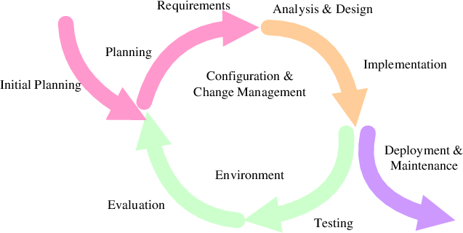**3.1 Software Development Model**

***Figure 1 Iteration Model***

Figure 1 Iterative and incremental development is a process that grows a system feature by feature during self-contained cycles of analysis, design, implementation, and testing that end in the production of a stable, fully integrated and tested. It is does not contain only one large development cycle as in the waterfall model. This model has separated a work into small task, and iteration it until developers satisfies a result; in each task iteration builds on the work of previous iterations and refines the system until the final product is complete.

**3.2 Software Tools Plan**

Draw io: an online diagram maker.

Chrome: a web browser. [Version: 80.0.3987.149 (64) bit]

GitHub: GitHub is a hosting platform for open source and proprietary software projects.

Trello: a web-based Kanban-style list-making application which is a subsidiary of Atlassian.

**3.3 Development Environment**

DESKTOP-TH73SEV

◆ Processor: Intel(R) Core (TM) i5-9400F CPU @ 2.90GHz

◆ Memory: 16.0 GB

◆ Graphics: NVIDIA GeForce GTX 1060

◆ Operating System: Windows 10

DESKTOP-O445M9U

◆ Processor: Core i7-7700HQ @ 2.80GHz

◆ Memory: 16 GB 2400 MHz DDR4

◆ Graphics: NVIDIA GeForce GTX 1050Ti

◆ Operating System: Windows 10

**Chapter Four**

**4.1 Quality Standard**

ISO 29110 is a guide applying to a very small entity, enterprise, organization, department or project up to 25 people dedicated to software development. The guide provides project management and software implementation process which integrate practice based on the selection of ISO/IEC 12207 systems and software engineering software life cycle process and ISO/IEC 15289 software engineering software life cycle process guideline for the content of software life cycle process information product (documentation) standards elements.

4.1.1 Project Management Process

The purpose of the software management process is to establish and carry out in a systematic way the task of the software implementation project that allows complying with the project's objectives in the expected quality, time and cost. Selected process

Activities:

project planning process

project plan execution process

project assessment and control process

project closure process

Chapter Five

**5.1 Communication Management**

1. Discuss with the advisor for approval on potential changes.
2. Developer records change information to the change document.
3. Developer sends change documents to the advisor to get approval.

4. Developer updates document and software follow change information.

**5.2 Naming Convention**

The naming convention for artifacts in this project will adopt this format.

[Project name] - [Document type]. [file type]

* + Project name – CAMT Exam Dashboard with Tesseract
  + Document Type - Depends on the content of the document.
  + File Type - Depends on the file type

**5.3 Project Repository**

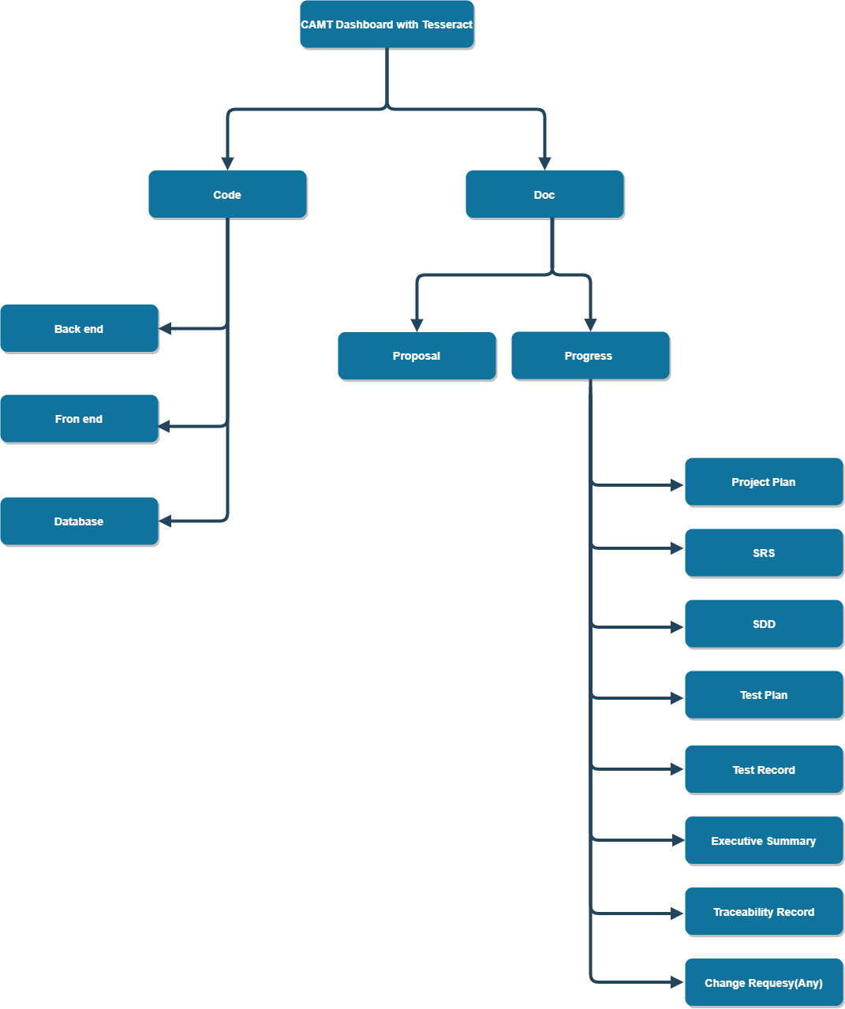

**5.4 Software Configuration Item Tabler**

|  |  |  |  |  |  |  |
| --- | --- | --- | --- | --- | --- | --- |
| No. | Item | File name | File Type | Owner | Path | Baseline Version |
| 1 | Project Proposal | CAMT Dashboard With Tesseract-Proposal_v[Version] | .docx | LK  JT | /Doc/Proposal | 1.0 |
| 2 | Project Plan | CAMT Dashboard With Tesseract -ProhectPlan_v[Version] | .docx | LK  JT | /Doc/ProjectPlan | 1.0 |
| 3 | Software Requirement  Specification | CAMT Dashboard With Tesseract -SRS_v[Version] | .docx | LK  JT | /Doc/SRS | 1.0 |
| 4 | Software Design Document | CAMT Dashboard With Tesseract -SDD_v[Version] | .docx | LK  JT | /Doc/SDD | 1.0 |
| 5 | Test Plan | CAMT Dashboard With Tesseract -TestPlan_v[Version] | .docx | LK  JT | /Doc/TestPlan | 1.0 |
| 6 | Test Record | CAMT Dashboard With Tesseract -TestRecord_v[Version] | .docx | LK  JT | /Doc/TestRecord | 1.0 |
| 7 | Traceability Record | CAMT Dashboard With Tesseract - Traceability Record _v[Version] | .docx | LK  JT | /Doc/ Traceability Record | 1.0 |
| 8 | Change Request | CAMT Dashboard With Tesseract - Change Request _v[Version] | .docx | LK  JT | /Doc/ Change Request | 1.0 |
| 9 | Executive Summary | CAMT Dashboard With Tesseract - Executive Summary _v[Version] | .docx | LK  JT | /Doc/ Executive Summary | 1.0 |

**Chapter Six**

**6.1 Schedule and Milestone**

|  |  |  |  |
| --- | --- | --- | --- |
| Milestone | Description | Milestone Criteria | Planned Date |
| M0 | Start Project | SE Senior Project Meeting | 19/04/2021 |
| M1 | Start Proposal | Project Topic Announced | 21/04/2021 |
|  |  | -Discuss scope & list features  -Prepare proposal & presentation |  |
| M2 | Start  Progress 1 | Proposal Presentation Result Announced | 26/05/2021 |
|  |  | - Re-submit proposal document  - Develop Progress 1  Feature 1 Authentication System  Feature 2 Table and cell detection and text extraction and parsing system  - Prepare presentation | 02/06/2021  To  10/08/2021 |
| M3 | Start  Progress 2 | Progress 1 Presentation Result Announced | 31/08/2021 |
|  |  | - Re-submit progress 1document  - Develop Progress 2  Feature 3 Dashboard System  Feature 4 Notification System  - Prepare presentation | 31/08/2021  To  22/09/2021 |
| M4 | Start Preparing for Show Pro | Progress 2 Presentation Result Announced | 23/09/2021 |
|  |  | - Re-submit progress 1document  - Develop Progress 2  Feature 1 Authentication System  Feature 2 Table and cell detection and text extraction and parsing system  Feature 3 Dashboard System  Feature 4 Notification System  - Prepare presentation | 23/09/2021  To  29/09/2021 |
| M5 | Release Product | Show Pro | 29/09/2021 |
|  |  | - Show Pro | 29/09/2021 |
| M6 | Start Final Progress | Show Pro Result announced | 30/09/2021 |
|  |  | - Review the entire project  - Do some fine-tuning | 30/09/2021  To  10/10/2021 |